**Figure 2:** Association between dry eye disease (DED), irritable bowel syndrome (IBS) and depression in presence of prevalence odds ratio (OR) and severity standardized mean difference (SMD). (A) Association between prevalence of DED in depression patients versus control group. (B) Association between prevalence of depression in IBS patients versus control group. (C) Association between prevalence of depression in DED patients versus control group.

A DEP->DED

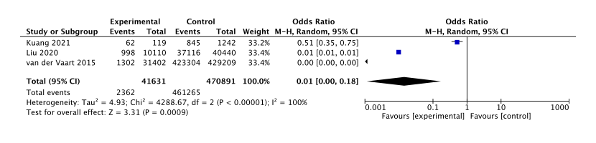

B IBS to DEP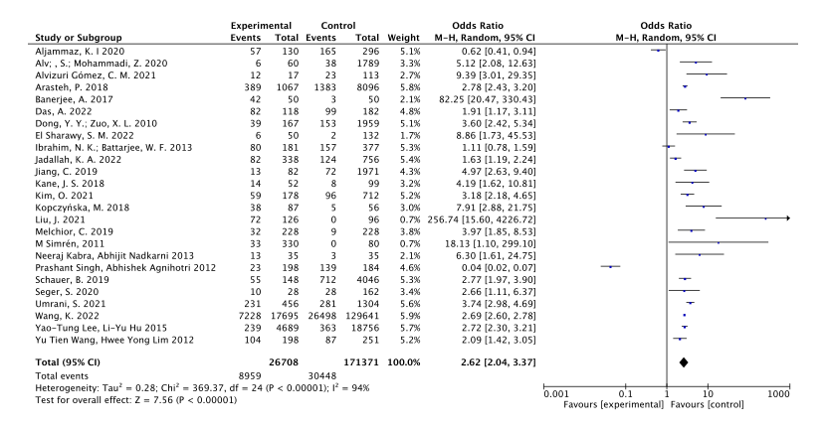

C DED->DEP

